## Government Polytechnic ,Washim

A

MICRO PROJECT REPORTON

**“CHAT APPLICATION”**



**Submitted By group of**

**1. Pavan P. Faltankar ( 1700310215)**

**2. SacchidanandB.Linge( 1800310215)**

**3. VaibhavS.Ingle( 1800310207)**

**4. PavanS.Ingole( 1700310216)**

***(Final Year Diploma in Information Technology)***

**Principal**

**Dr. V.R.Mankar**

***( GovernmentPolytechnic, Washim)***

**DEPARTMENT OF OF INFORMATION TECHNOLOGY**

**2019- 2020**



**Government Polytechnic,Washim CERTIFICATE**

**This is to certify that**

**1. Pavan P. Faltankar**

**2. SacchidanandB.Linge**

**3. VaibhavS.Ingle**

**4. PavanS.Ingole**

**From Government Polytechnic, Washim has partially completed project planning report having “CHAT APPLICATION” in a group consisting four candidates under the guidance of the Mr.Y.J.Bhopale.**

**Guided By HOD**

**Mr. S.S.Gharde** **Mrs M. R. Lolure  
*( Lecturer in Info. Tech. Department)*** *(I/C HOD ,Information Technology Department)*

**Principal**

**Dr. V.R.Mankar**

***( GovernmentPolytechnic, Washim)***

**DEPARTMENT OF INFORMATION TECHNOLOGY**

2019-2020



**CONTENTS**

|  |  |  |
| --- | --- | --- |
| **SR.NO.** | **INDEX** | **PAGE NO.** |
| **1** | **ACKNOWLEDGEMENT** | **4** |
| **2** | **ABSTRACT** | **5** |
| **3** | **INTRODUCTION** | **6** |
| **4** | **LITERATURE SURVEY** | **6** |
| **5** | **PROBLEM DEFINITION** | **7** |
| **6** | **METHODOLOGY** | **7** |
| **7** | **FLOWCHART** | **9** |
| **8** | **DFD** | **10** |
| **9** | **USECASE** | **11** |
| **10** | **RESOURCES** | **12** |
| **11** | **ACTION PLAN** | **13** |

**ACKNOWLEDGEMENT**

If words are considered as symbol of approval and token of application then let the words play the herel ding role expressing my gratitutde

The satisfaction that a companies that the successful completion of any task would be uncomplete without the mention of people whose caseless cooperation made it possible whose constant guidance and encouragement crown all efforts with success. We are greateful to our project guide **Mr.Y.J.Bhopale** for the guidance,inspiration and constructive suggestion that helpful us in the preparation of

these project. We also thank our colleagues who have helped in successful completion of the project.

**Abstract**

This project established how LAN Chat Messenger using Rational Unified Process (RUP) methodology provides low-cost communication between staff in an organization. In the process, it enables users to make, chat and transfer of small to medium-sized files. chat conversations are saved and quick file transfers are made through chat application which minimizes the communication issues, which are mainly time and cost of communication and maintenance. Object oriented programming was used to develop the system chat application and the programming language utilized was JAVA, focused on the implementation of two-tier architecture within TCP/IP. The system was implemented based on a standalone application using pure object oriented language. This system was successfully tested at one of the organizations for the domain study.

**Introduction**:

A LAN messenger is an instant messaging program designed for use within a single local area network

(LAN). Many LAN messengers offer basic functionality for sending private messages, file transfer, chat rooms and

graphical smileys. The advantage of using a simple LAN messenger over a normal instant messenger is that no

active Internet connection or central server is required - and only people inside the firewall will have access to the

system.

LAN messenger is an easy to use, server based LAN messaging application for effective communication. It

is correctly identified and works under all operating systems with unlimited user accounts and is the only secure

messenger. The simple interface makes special training needless.

**Literature Survey:**

The chat application uses two-tier client server architecture. The application handling is completed

separately for database queries and updates and for business logic processing and user interface presentation.

Generally, the networks bind the back-end of an application to the front-end, though all tiers can be present on the

same hardware. The architecture of any client/server situation is by classification at least a two-tier system, the client

is the first tier and the server is the second.

The two-tier design generally encompasses client demanding services undeviatingly from server i.e. client

communicates alongside the server without the help of another server or server process (Chandra & Kumar, 2009).

**PROBLEM DEFINITION:**

This project is to create chat application with server and clients to enable the client to chat with many other clients in the same common chat group

This project is to simulate the multicast chatting.In the case of multicasting when a message sent to a group of clients,then only a single message is send to the switch.

The main purpose of these project is to provide multichatting functionality through network.

This project can play an important role in organizational field where employees can connect together through LAN.

**PROPOSED METHODOLOGY OF SOLVING IDENTIFIED PROBLEM**

To implement these objectives we use different programming languages like JAVA, etc.

here we use java language to implement it.

Software requirement:

1. MS Access

To implement this work we require different module like user module, Administrator Module.

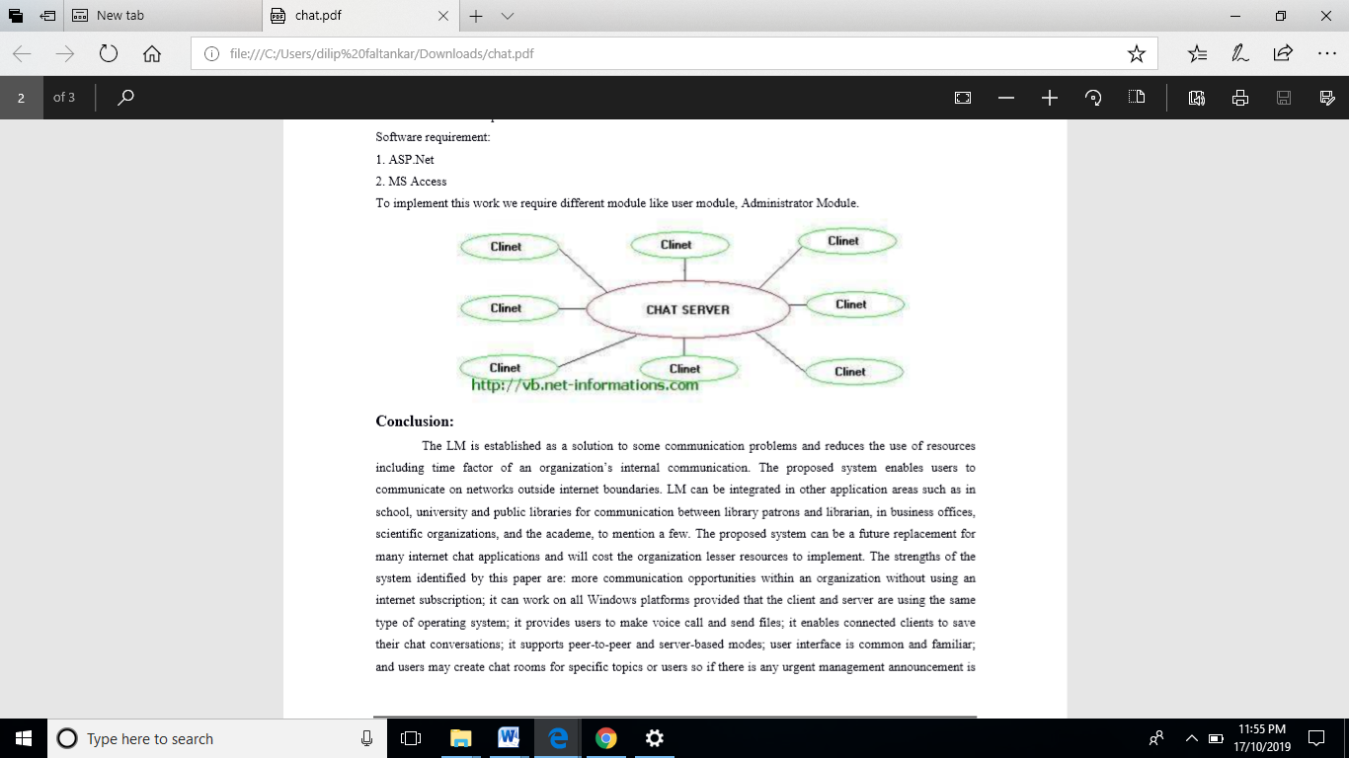

**Hardware and Software Requirements :**

Minimum 2 PC’s  
Minimum 40 GB Hard Disk  
500 MB RAM  
Windows XP Service pack 2  
LAN Connection  
Visual Basic 6.0

**COST FEASIBILITY:** In this project we are going to implement chat using LAN which is already present in our institute that’s we don’t need to create new LAN .Hence due to low cost we can implement it easily.

**HARDWARE FEASIBILITY:** To implement our project we need minimum two computers connected in LAN.As we implement this project for institute level, there are numbers of computer systems are available in institute that’s why, Here also we need not to increase our budget.

**FLOWCHART:**

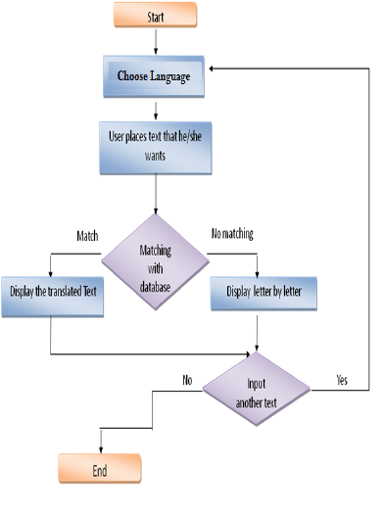

**DFD DIAGRAM**

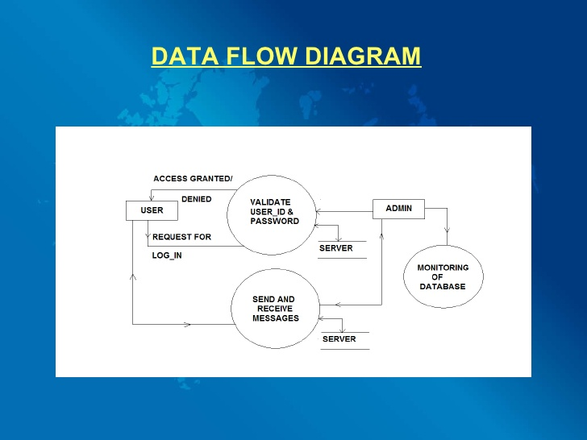

**USE CASE DIAGRAM**

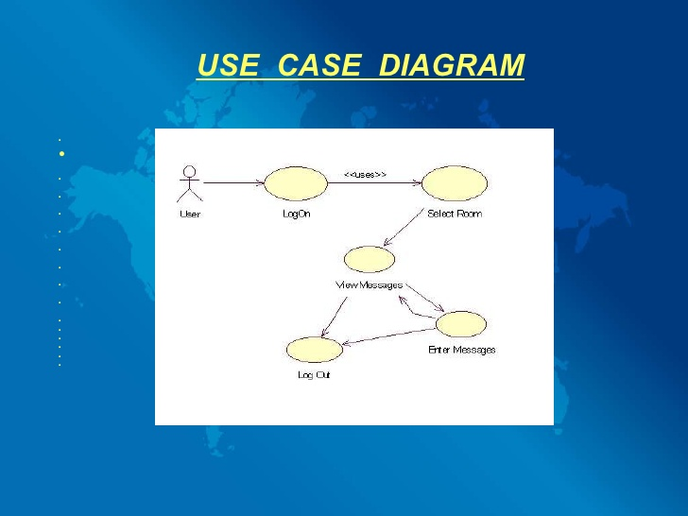

**Action plan:**

**Instant Messaging:** You can instantly connect with other users on the network and start a conversation.

**Private Network:** No need to worry about your privacy. AES encryption with RSA offers industry-leading security.

**Broadcast messages:** You will have the option to notify all users within the network or choose specific users.

**Transfer Files:** Forget about email attachments. This app makes it easy and hassle-free to transfer files to other users within the network.

**Group Contacts:** You can also easily organize people in your contact list. This will make it easy to find people when needed.

**Log Messages:** Previous conversations can also be archived, which you can access at any given time.8

**Works without Server:** One of the best things about this instant messaging application is the lack of server that is required, making it less complicated.

**Works without Internet Connection:** This messaging application utilizes a local network, which means that you can send messages even without internet, which is beneficial in minimizing possible threats.

**Multi-platform Support:** Regardless of your operating system, whether you are on Mac, Windows, or Linux, you can use this messaging application.

GANTT CHART

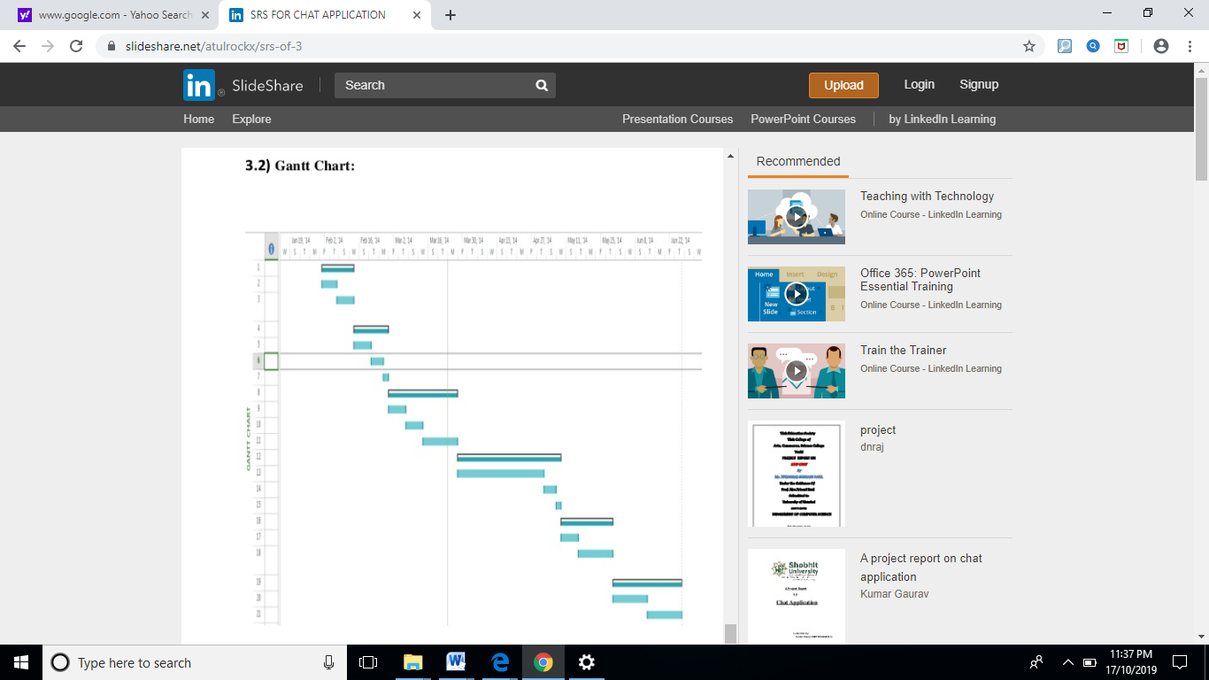

**WEEKWISE ACTIVITY**

